**Transportation module “Modifications”**

* Bus Expenses should be not in that place of menu:-
* It should be recorded **under the daily journals of the Treasury**.
* It can also be assigned a cost center within the cost centers and thus save time and effort in design and also in use.

The following map can be guided to design the rest of the required parts

**Signup**:  
- fill the grid of students according current Year and Grade.

* Report about Bus and its students

**Stud to Bus**:  
-When click the student “**assign stud to Bus FORM”** will show and will contains all info about the available buses to the student in a popup “Busses in a list and ways in a map ” according his registered address “Google map” may we will apply register address of the student page to use Google map selection.

* After select the system will add the daily journal of the amount which paid according dropLists of depit and credit.
* The droplist show these accounts if it inserted as default and he can select another
* Depit DropList “Accounting receivable parents” account
* Credit DropList “Unearned bus revenues” account

**Setup** :

- Drivers Reg/Edit Form “with Grid **Export** button”

- Supervisors Reg/Edit Form “with Grid **Export** button”

- Bus Registration/Edit Form “with Grid **Export** button”

* Contains the bus info ,choose driver,choose supervisor, count of sets available and **Travel Ways “with choose from google map** “start point - end point”” with cost and discount textboxes..
* Show in middle of the form “Google map” with all the registered Bus ways which registered As:

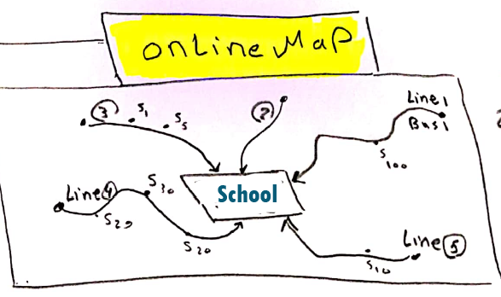

**Inventory Module “Modifications”**

It has pages for industrial companies that collect and manufacture raw materials and convert them into a final product ………. This is not required in schools please remove from menu

The rest of the existing according to the following map:

**Items:** ok **but**  
* add new page as Items Groups.

*And inserting new item will choose its group

**Stores:** ok  
- Locations

-Employees

-Others

**Receive Items:**ok but:  
*Supplier should be dropList

*Remove currency.

*Items should be from dropList.

According choose iten the itemNO, description, unit name, and unit price will be filled automatic, and can Edit in unit price.

**A: Custody:**

Custody out to employees for use

**Output Items:** not Exists  
it contains the Exchange operations out from the stores.

**B: Normal out Requests:**

Like tea, Coffee, Pens, clean tools … etc

**C: For Students:** Exists in students But:

For the student:

If Grade Fees items like (Books, Uniform) assigned to him >> It should be shown in the first rows of Purchase screen in student page for that student with status Pending to be received.

**Store Journals**:

For any transaction for the store should be a daily Journal for decrease from Store goods in **A** or **B** or **C**

**Store Reports**:

For all Previous screens (Recived,output,items,…etc)

**Incorrect forms should be updated:**

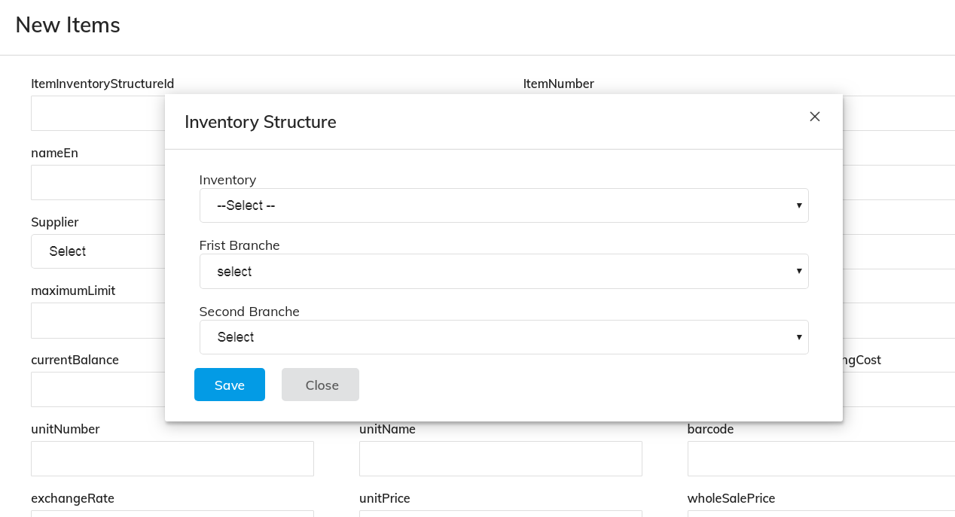

* Please update the labels to space between words as user interface
* When choose inventory structure should get to the textbox after popup go.
* (Remove unit number) and unit name should be dropList

When edit the existing item, it add new one!!

